KEN AND HELEN'S
WINDOW CLEANING
Do you want…
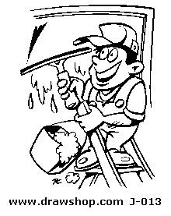

A Regular Window Cleaner?

Who is Fully Insured?

Who Take Pride in Their Work? ____________________________________

We are a family based business – already well established in your area.
Phone Ken or Helen for a free quote on:

Home: XXXXXX
Mobile: XXXXXXX

